**Assignment 1 – Module 5**

**Query for Problem 5:**

**INSERT INTO FACILITY (FACNO,FACNAME)**

**VALUES (‘F104’,’Swimming Pool’);**

**Snapshot for the Problem:**

1. **Before Inserting**

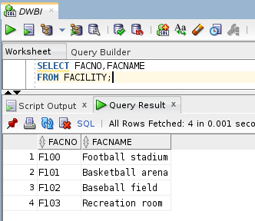

1. **Executing Insert Statement**

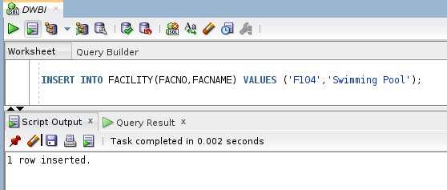

1. **After inserting**

